**SE3330 Course Project Iteration Planning Record**

**Iteration**: Iteration 1

**Team name**: SNAL

**Team Leader**: Logan

**Date**: 2/19/2020

1. **Sprint Backlog: (a screen shot of your sprint backlog)**

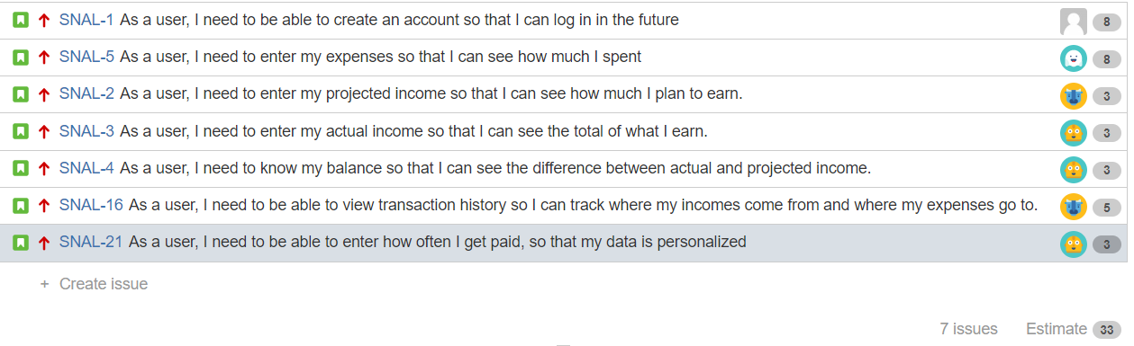

1. **Task breakdown:**

|  |  |  |  |
| --- | --- | --- | --- |
| Story ID | Tasks | Assigned to | Estimated Time |
| SNAL-1 | User class | Logan | 3 hours |
| Email notification | Logan | 2 hours |
| UI | Logan | 2 hours |
| SNAL-5 | Expense class | Andi | 5 hours |
| UI | Andi | 2 hours |
| SNAL -16 | UI | Nathan | 4 hours |
| SNAL - 2 | UI | Nathan | 3 hours |
| SNAL - 3 | UI | Sammy | 1 hour |
| SNAL - 4 | UI | Sammy | 1 hour |
| Calculate function | Sammy | 1 hour |
| SNAL - 21 | UI | Sammy | 1 hour |
| Calculation function | Sammy | 2 hours |

1. **Individual Assignment Summary**

|  |  |  |
| --- | --- | --- |
| Team Member | Assigned Tasks (ID) | Total estimated time |
| Logan | SNAL-1 | 7 hours |
| Andi | SNAL-5 | 7 hours |
| Nathan | SNAL-16, SNAL-2 | 7 hours |
| Sammy | SNAL-3, SNAL-4, SNAL-21 | 6 hours |